# CSA SCENERIO-CASES

1. Import your batch members as 20 users into your personal developer environment through import set
   * 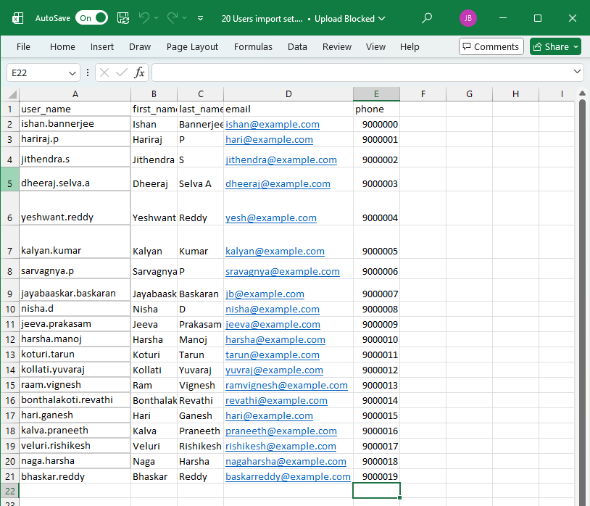Import data – Excel Format
   * 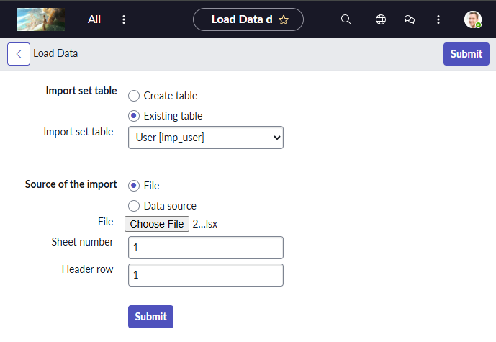To import data from excel sheet : All > Import Sets > Load Data
   * 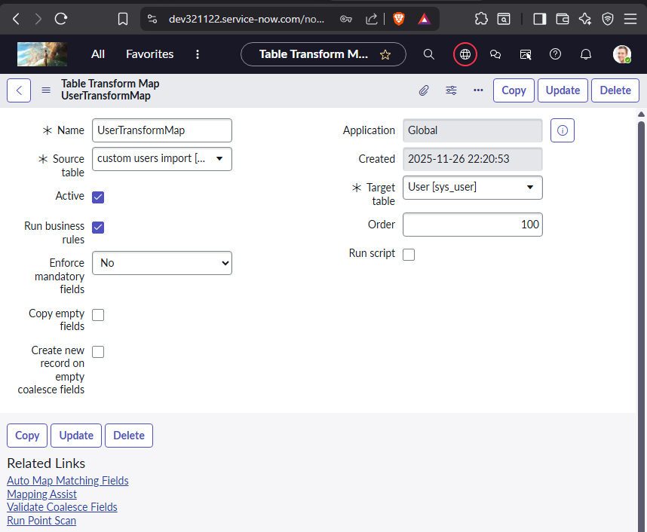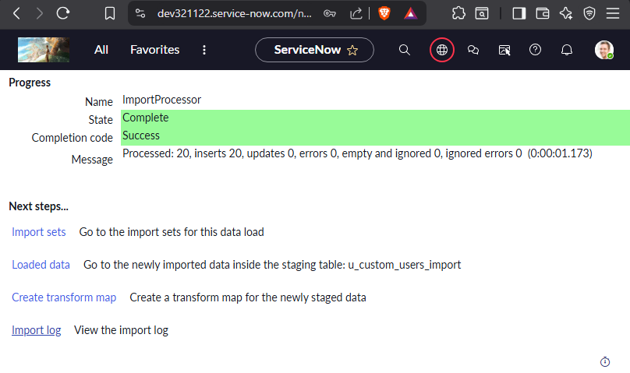Create Transform Map for Mapping fields
   * 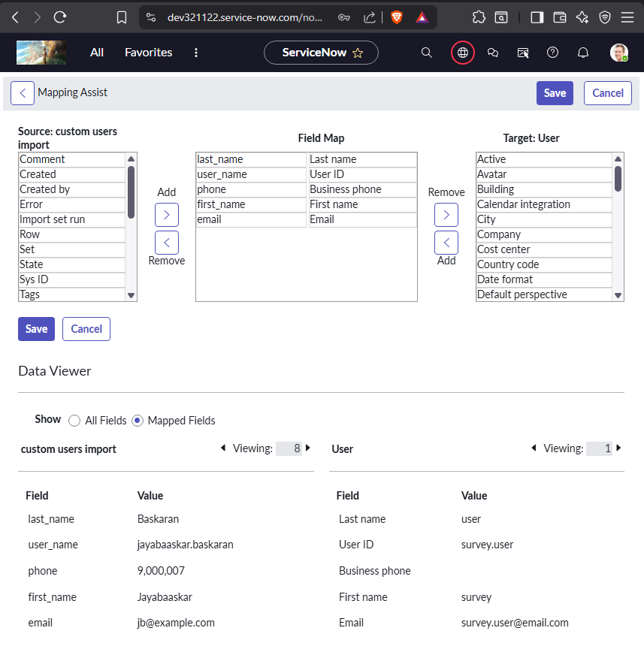Using Mapping Assist Map fields properly
   * 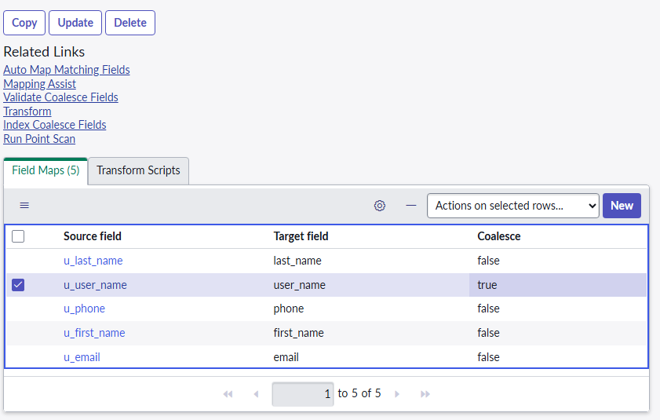Check the Coalesce Field true for the Unique fields to make sure there are no duplicates in the future and to update
   * 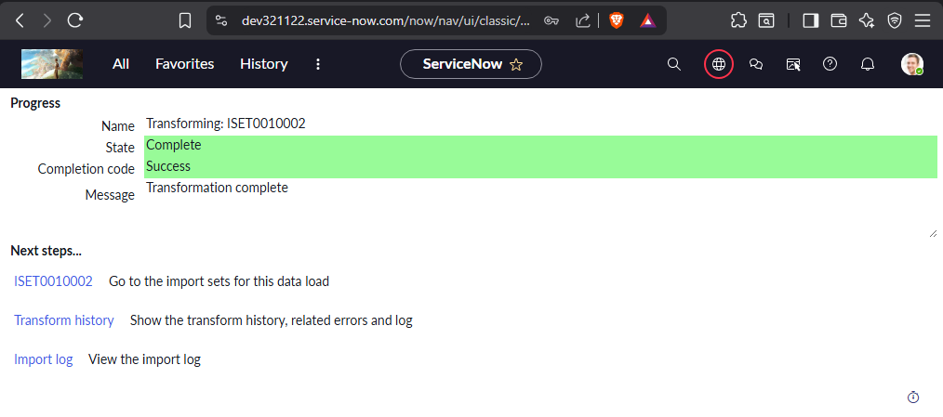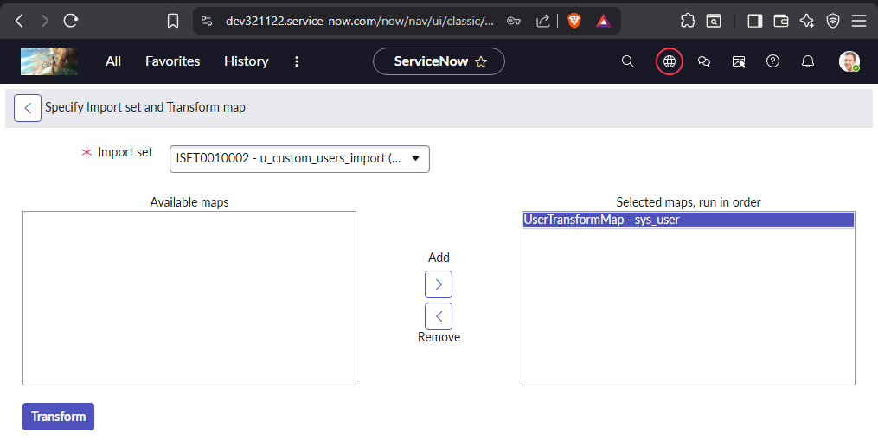Run the Transform Map Created
   * 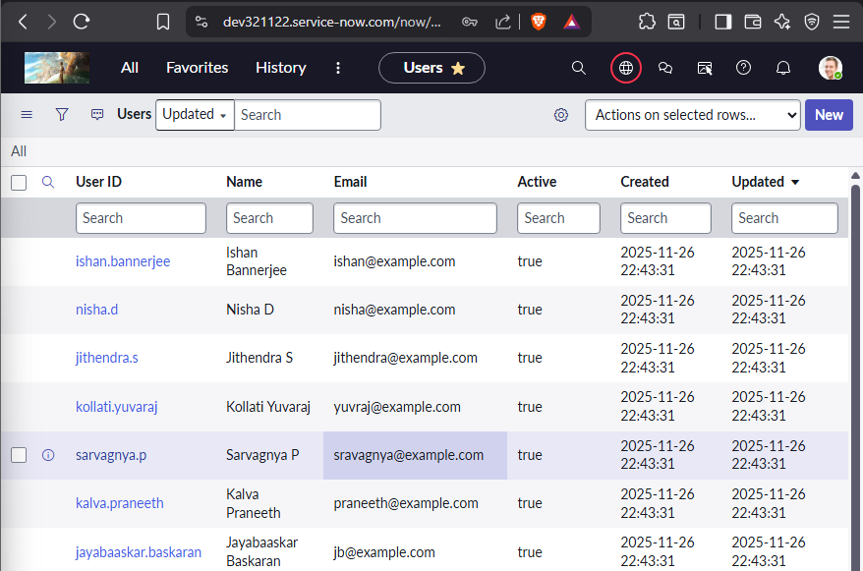Check the User table for imported Users and details.

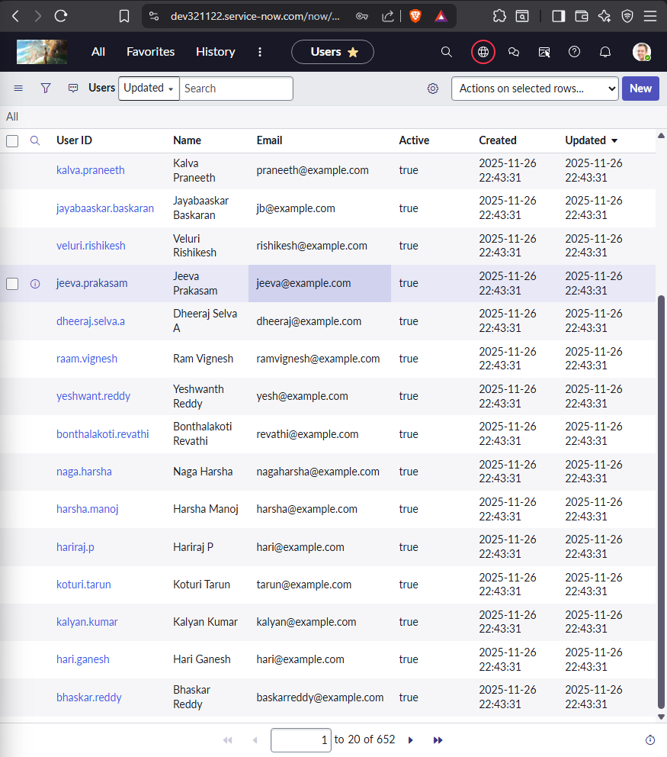

1. Create 3 groups called Batch-1 and Batch-2 and Batch-3.
   * Go to Groups under User Administraion – All > User Administration > Groups >New
   * 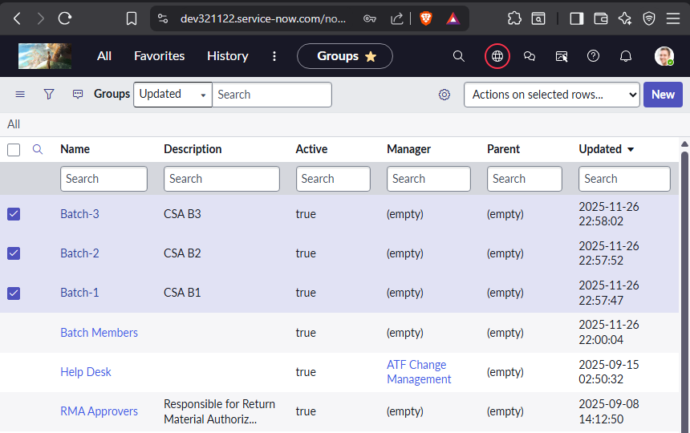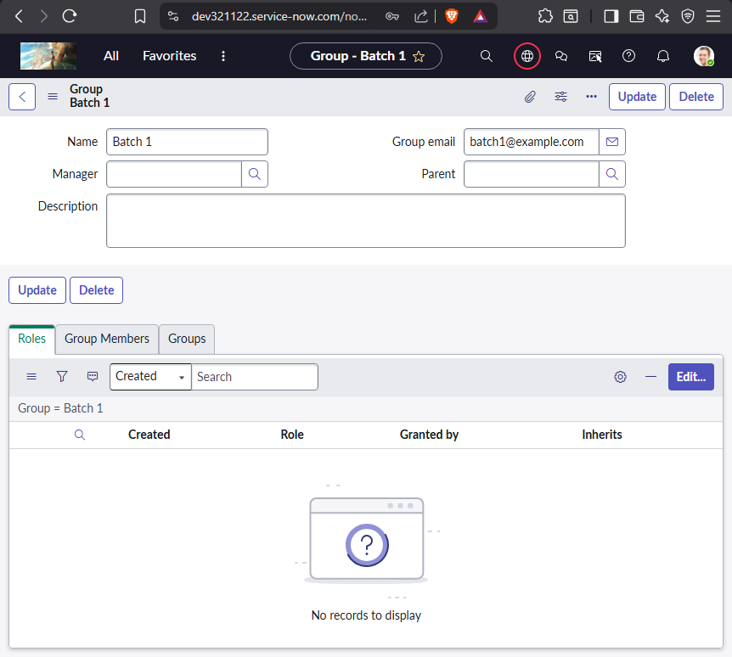Table Name: sys_user_group
2. Create Assignment lookup rules when category is software the assignment group should be software.
   * Go to Assignment Data Lookup table – table name – dl_u_assignment
   * 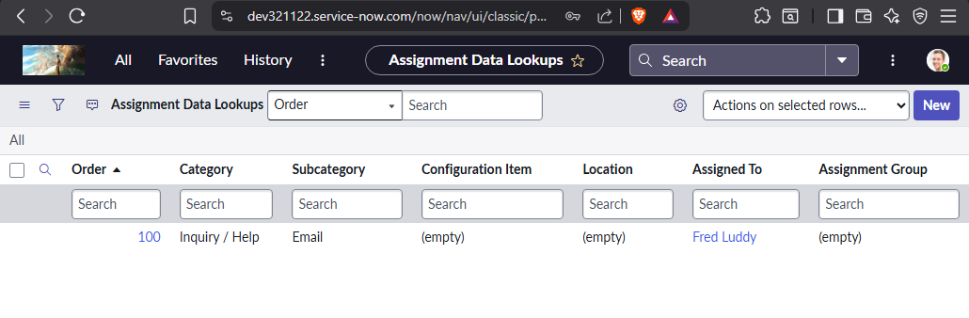Type dl_u_assignment.list on All Filters and Enter to open the table.
   * 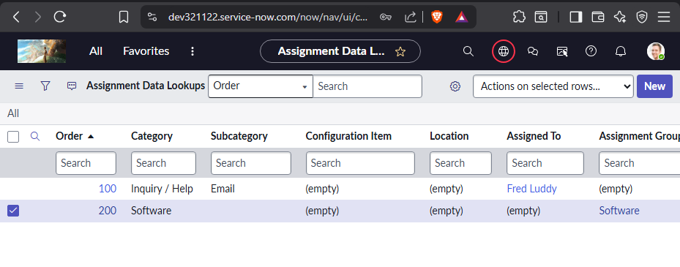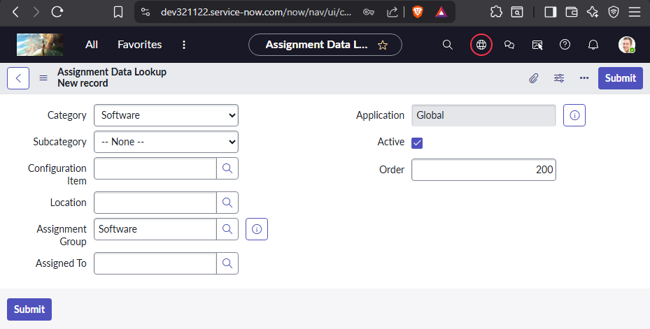Create New Data Lookup for Software
   * 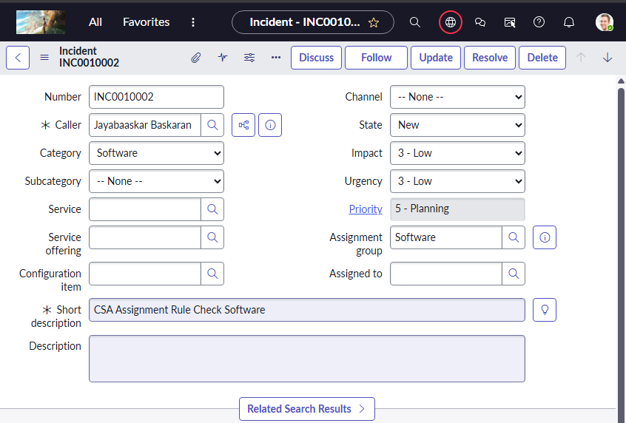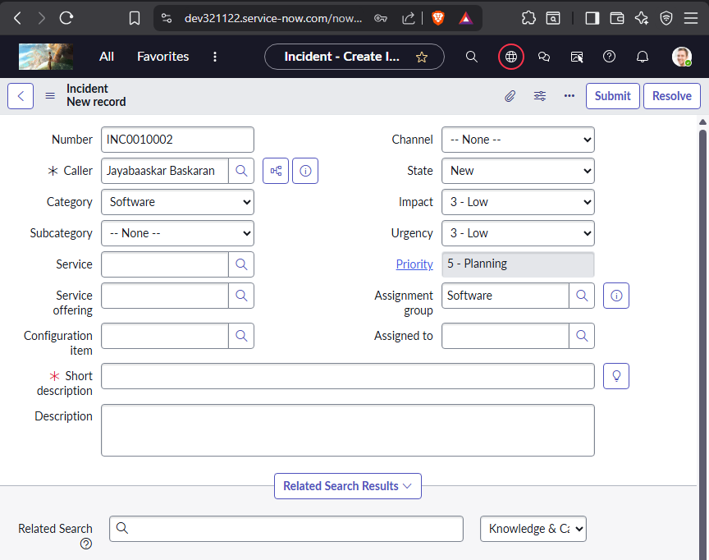Check If the assignment work in Incident Table
3. Create a custom table to store Credit card request details.
   * 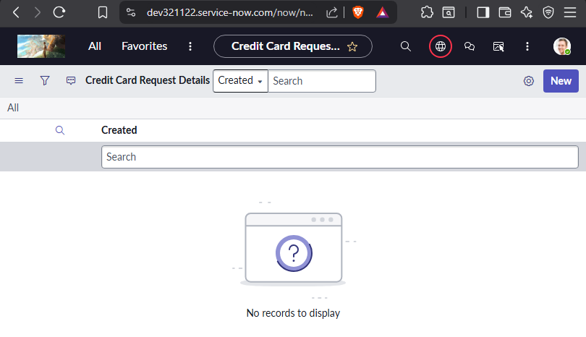custom table name – u_credit_card_request_details.
   * 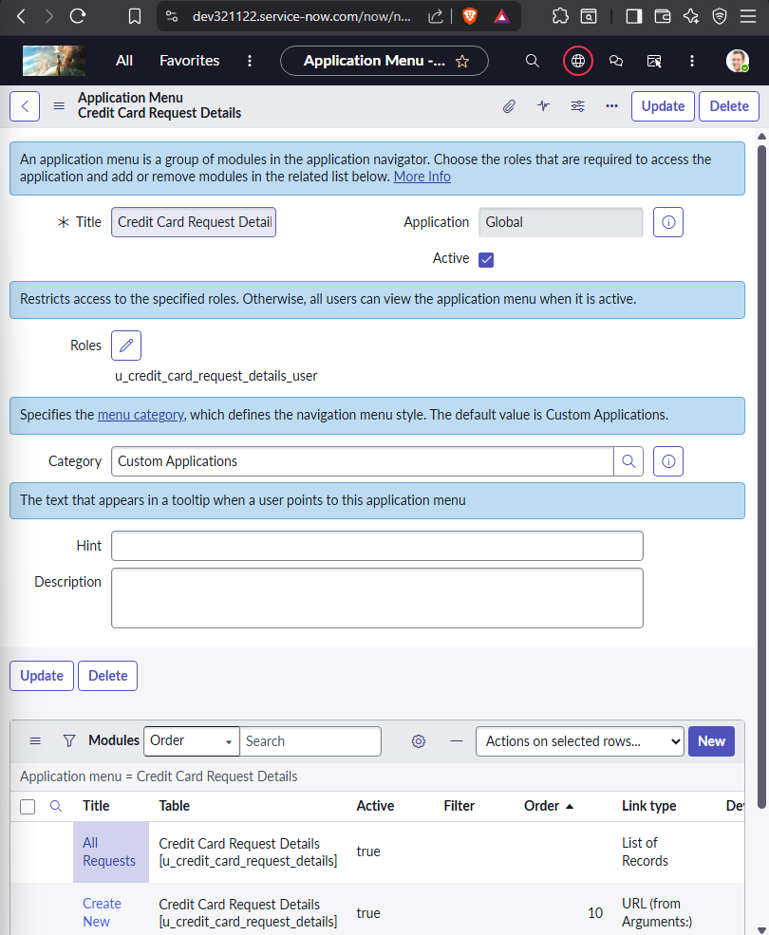Along with an application with the same name is created
   * 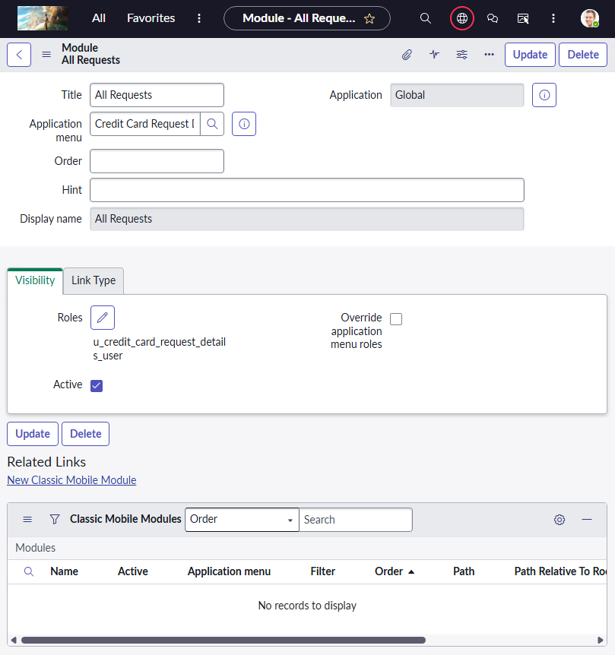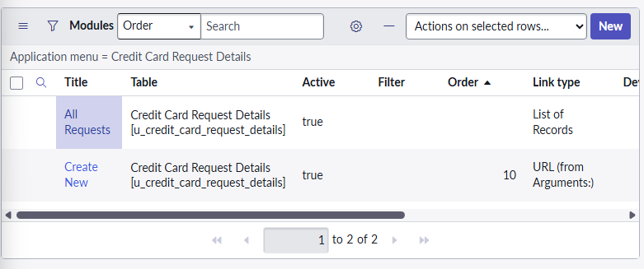Module –Create New & All Request & My Request
   * 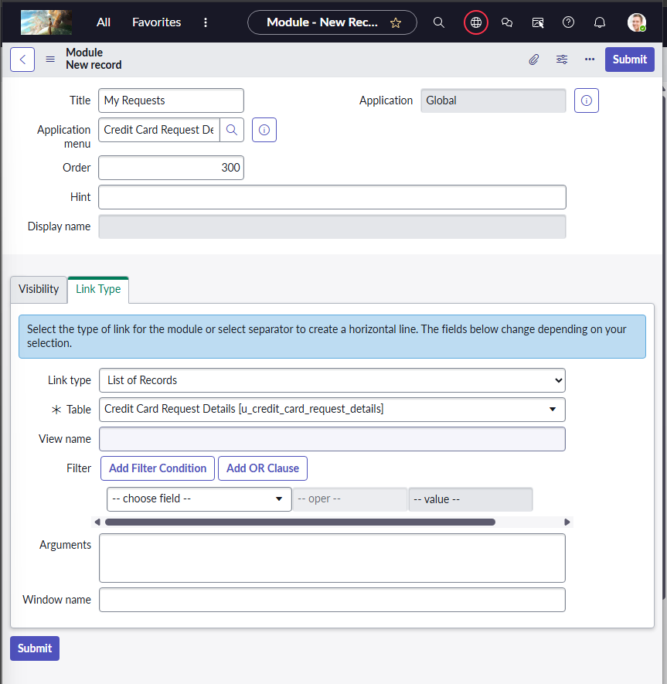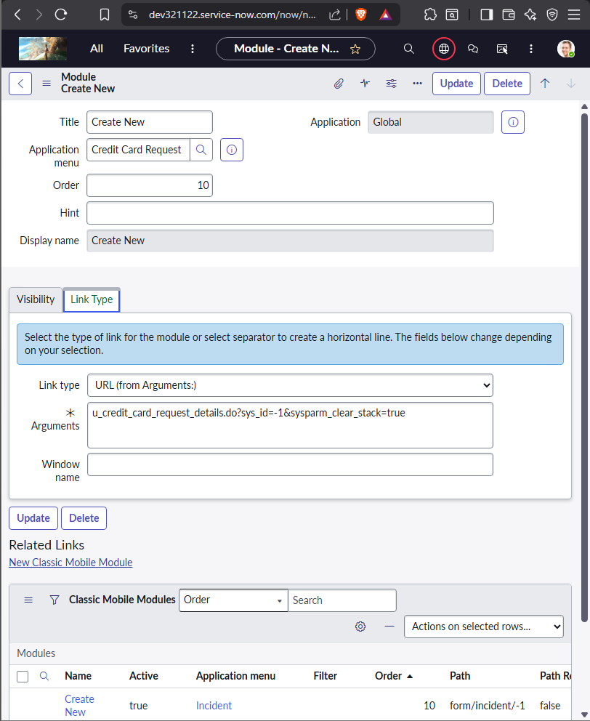Add Link type URL and in Arguments add the Form link Suffix for Create New
   * 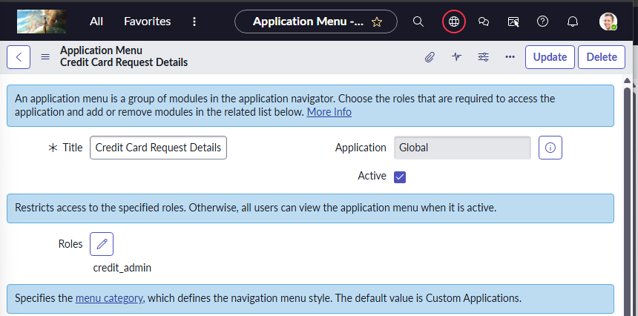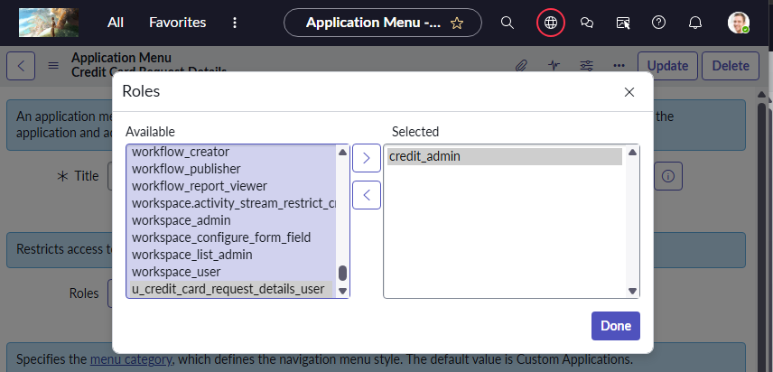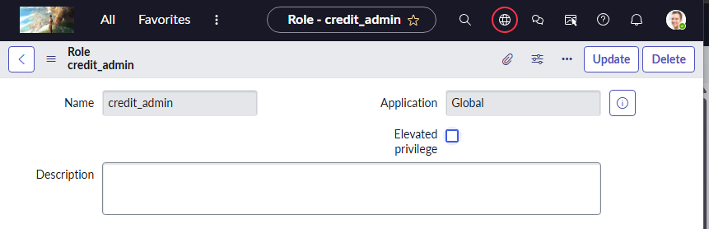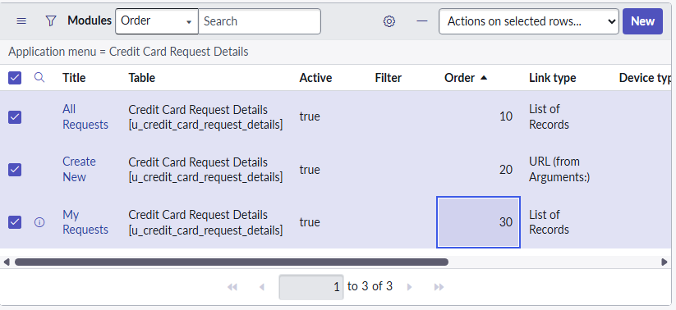Custom Role Creation credit_admin for application
   * 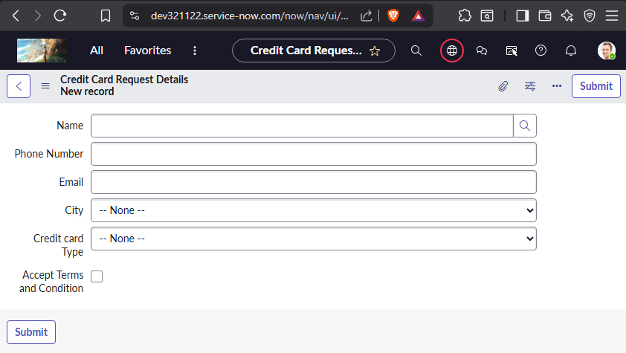Required fields: 1) Name: refer to user table. 2) Phone Number: String 3) Email: String 4) City: Choice type –All metro cities. 5) Credit card Type: any 4 choices as your wish. 6) Accept Terms and Condition: check box
   * Using Either Form Builder or Form Layout create Fields add choices
   * 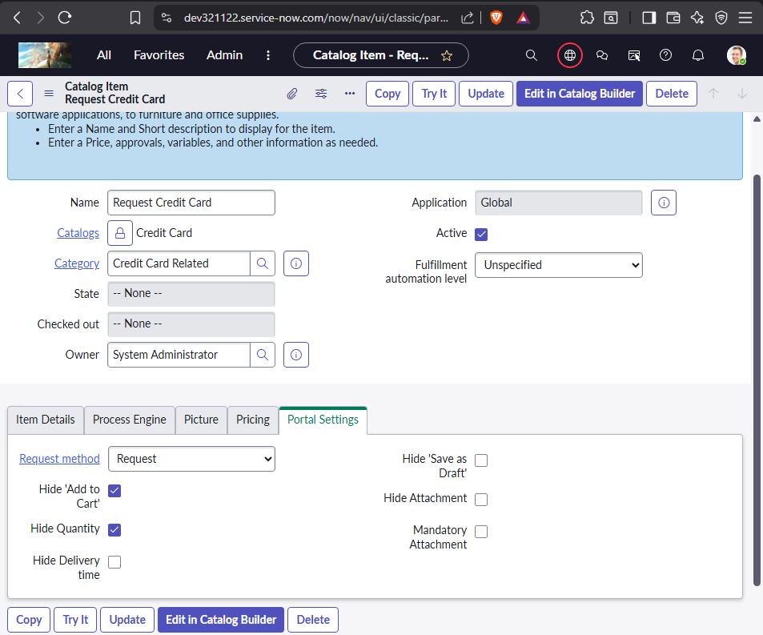Create catalog to request credit card *Required Variables 1) Name : refer to user table.-→mandatory 2) Phone Number : String 3) Email : String 4) City : Choice type –All metro cities. 5) Credit card Type: any 4 choices as your wish. 6) Accept Terms and Condition : check box-→if not accepted then catalog should not be submitted and need to alert user “please accept the T&C”

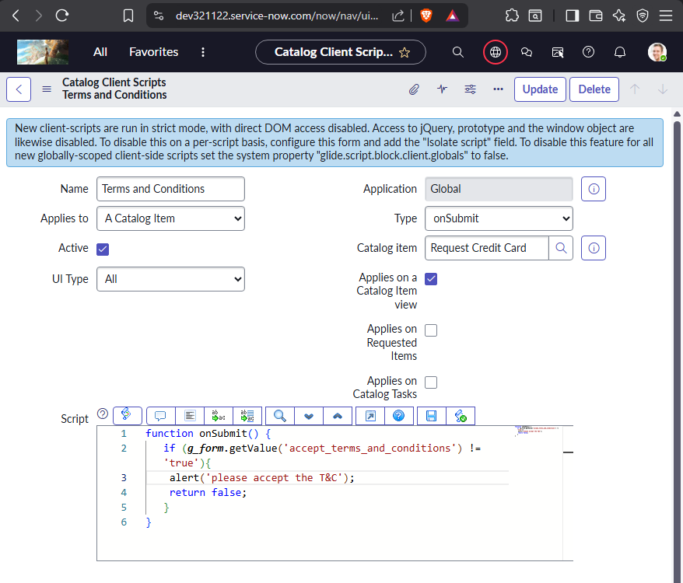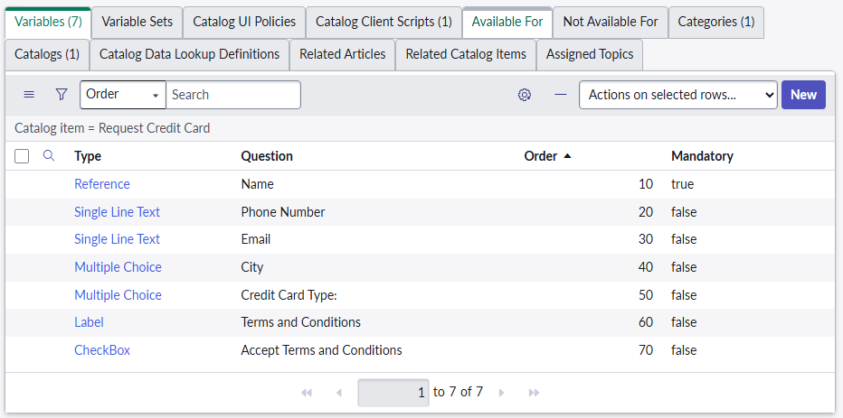

* + 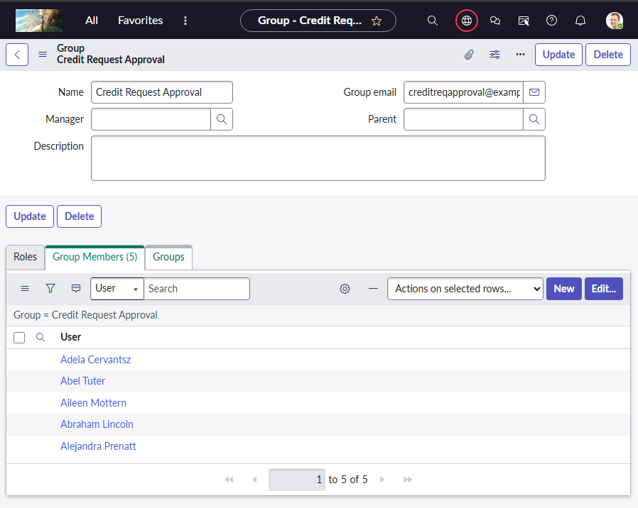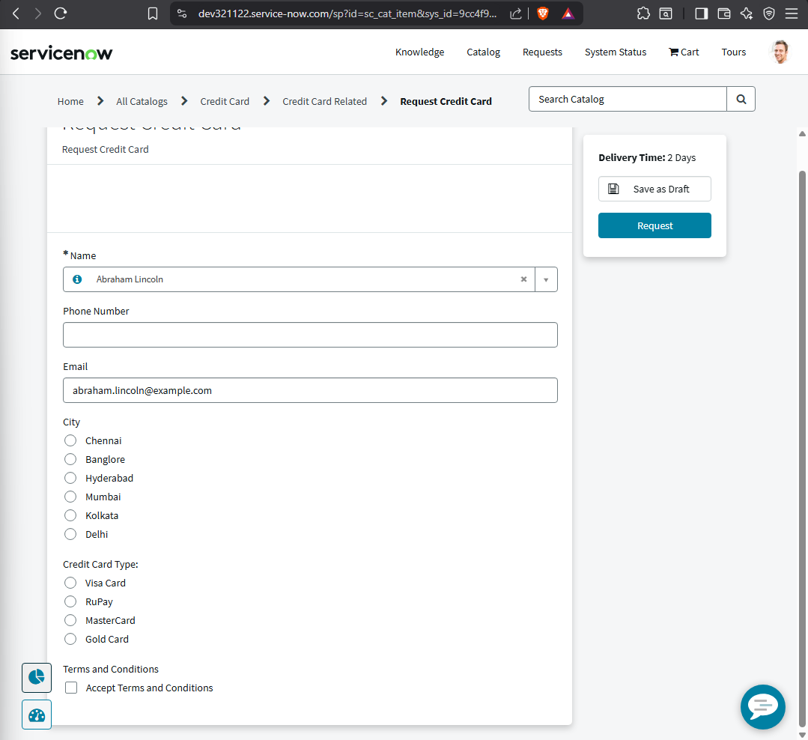Create Group Credit req approval group. Add the few user to this group.

1. Once user requested the credit card service it should go approval for Credit req approval group.
   * + 1) If approval approved then need to create a document verification task.
     + 2) if rejected or completed then notify the user with rejected content or approved content.
     + 3) if task completed successfully then create a delivery task.
     + 4) if delivery task completed then need to close RITM and Req records.
     + 5) if delivery task closed incomplete, then notify user req has not been processed and incomplete the req and ritm.
     + 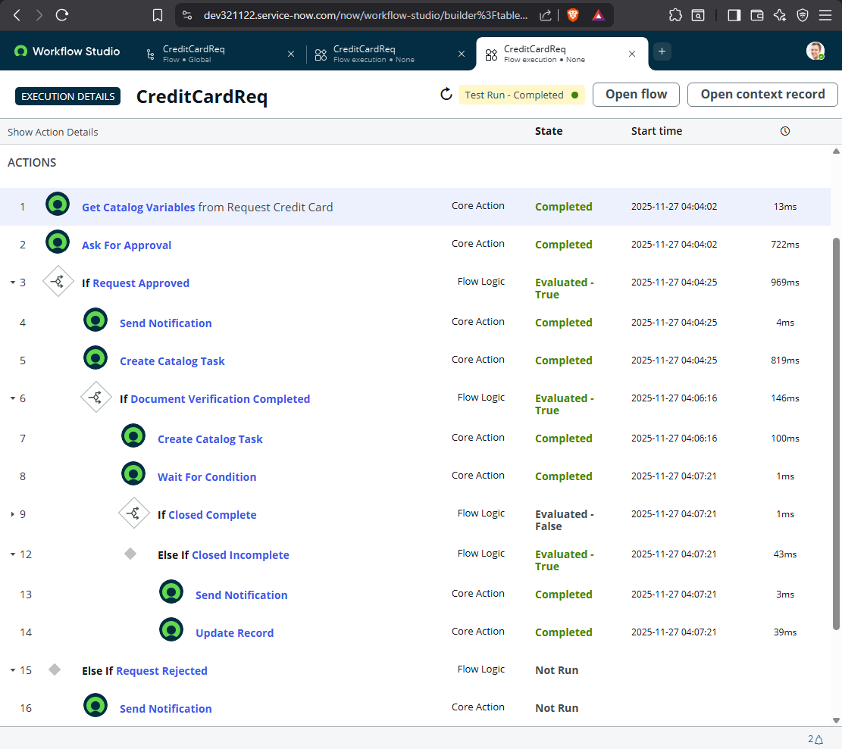6) The Assignment group for above tasks should be i.e., Credit req approval group.
     + 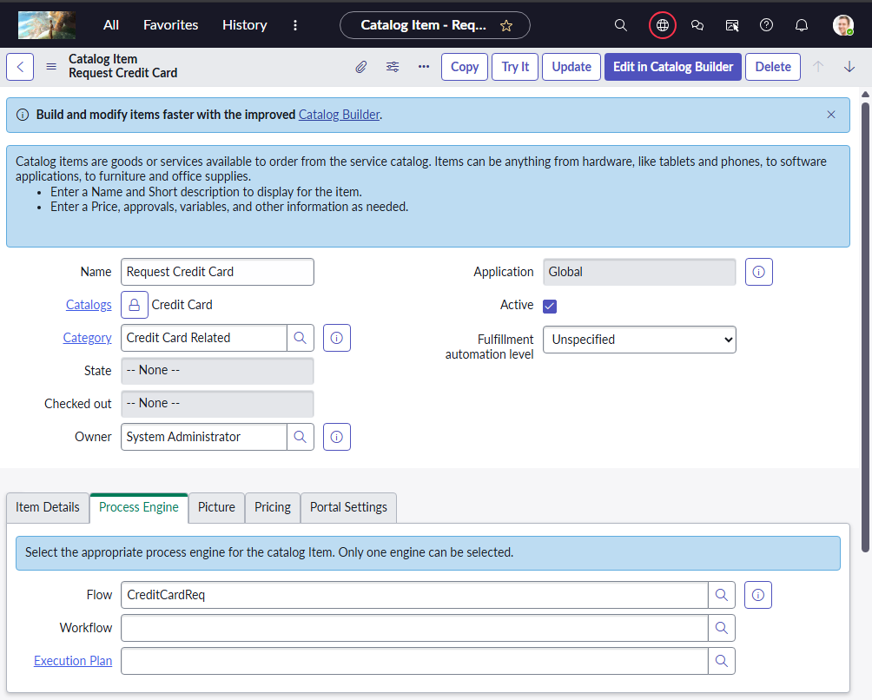Attaching the flow as Process Engine
     + 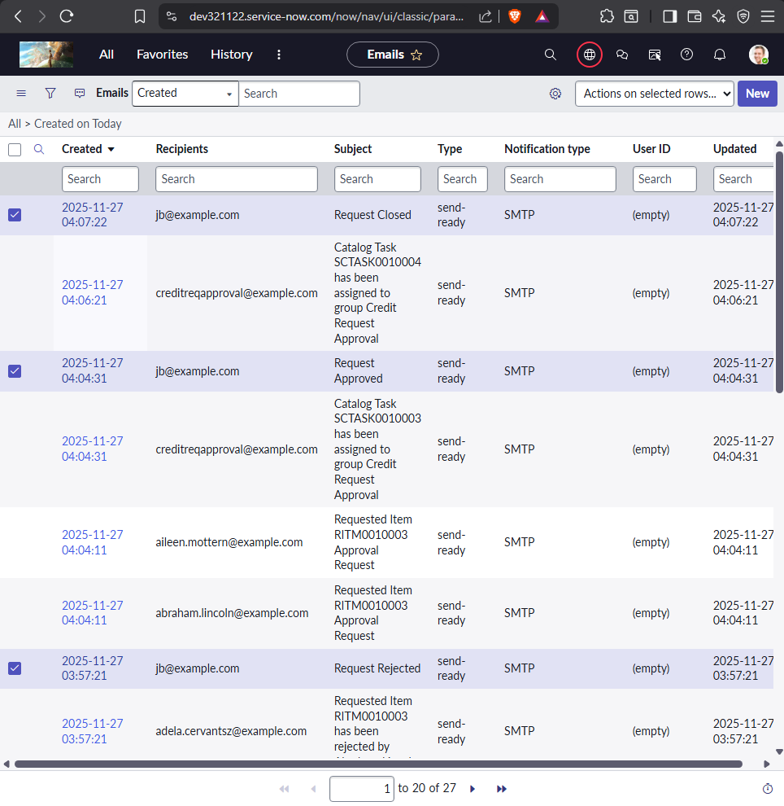email trigger for the user
2. 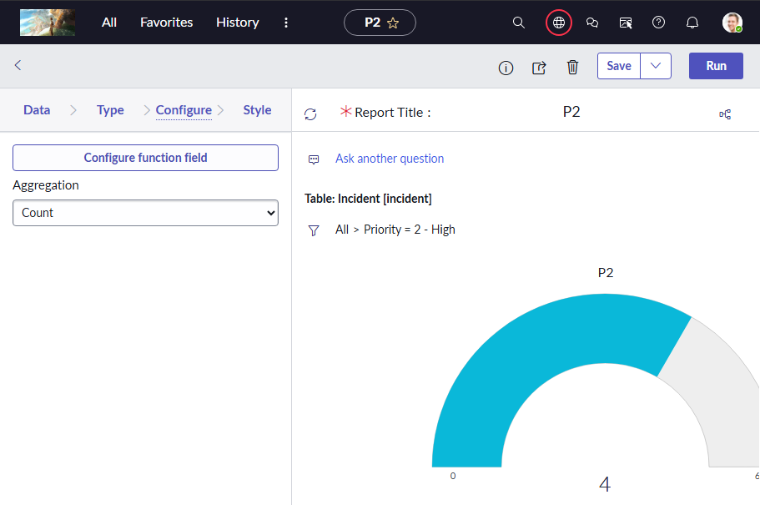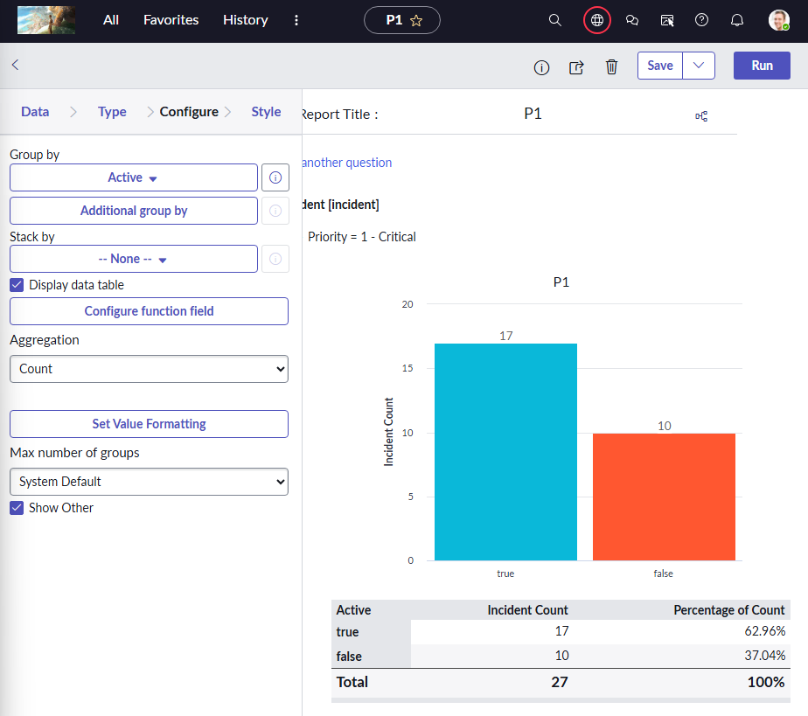Create A dashboard called Incident Priorities. ADD a P1 P2 P3 report of count type to respective dashboard.
   * 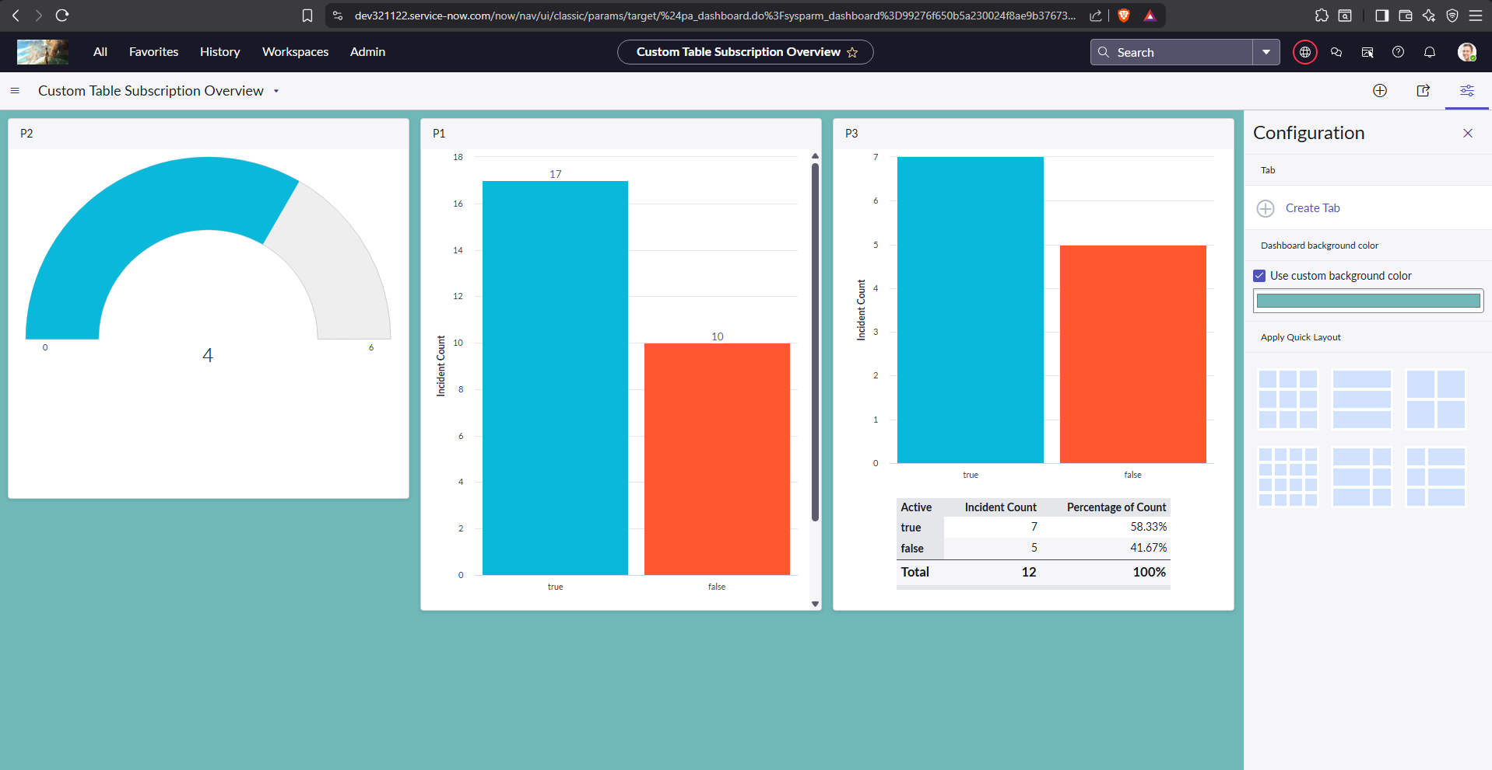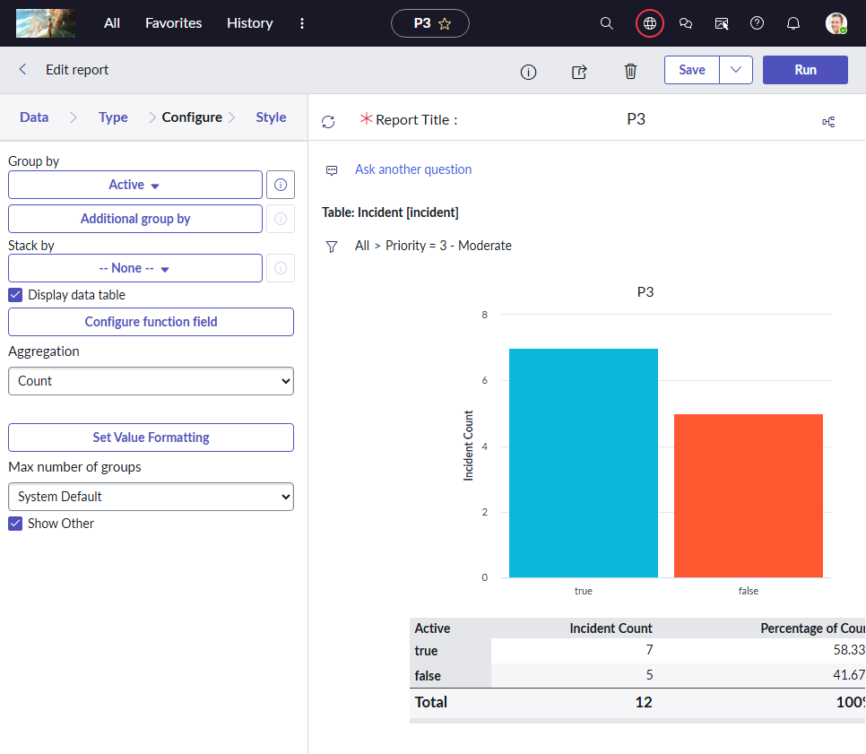DashBoard
3. Create a P1 , P2 , P3 reports , schedule it and send to one user
   * 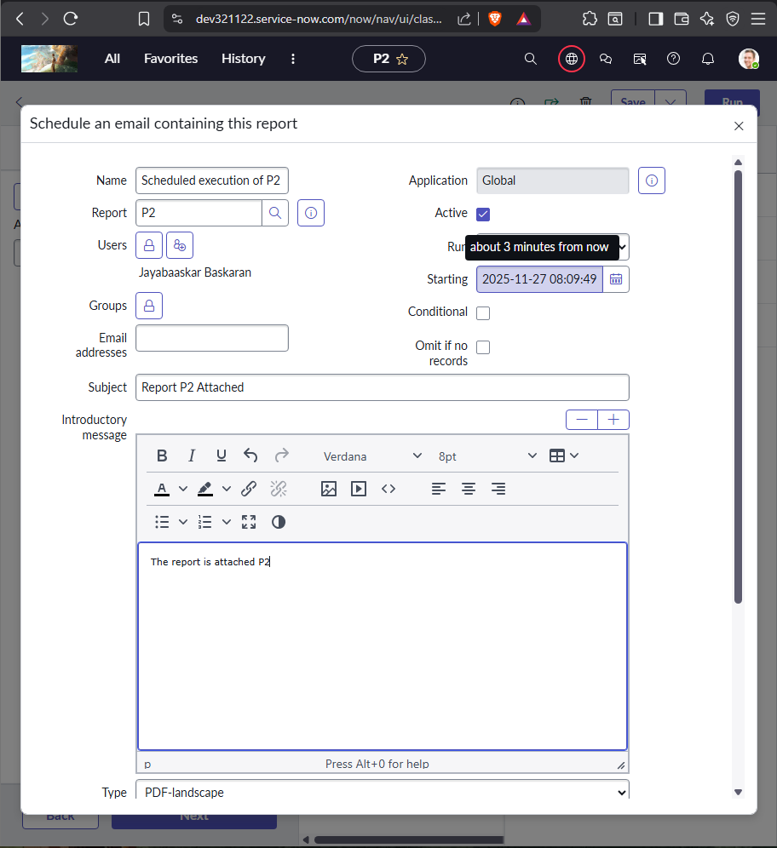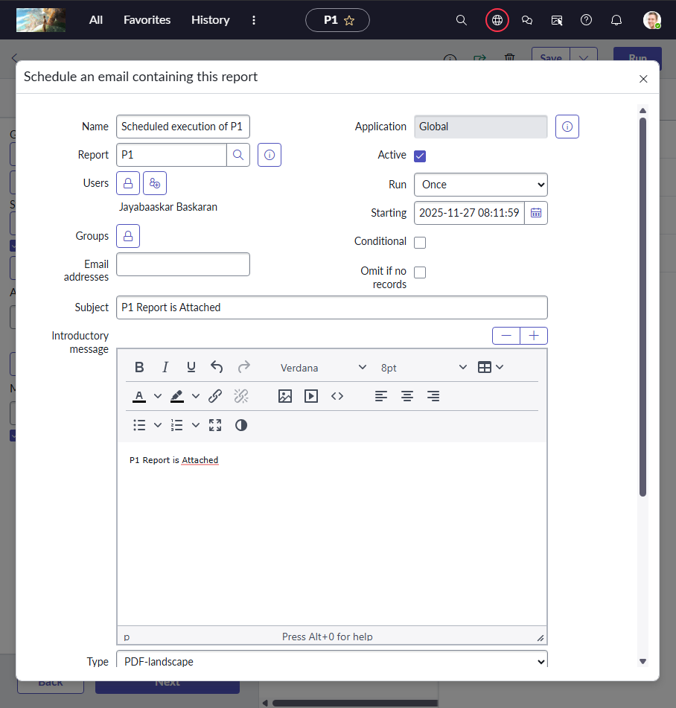Scheduling Report
   * 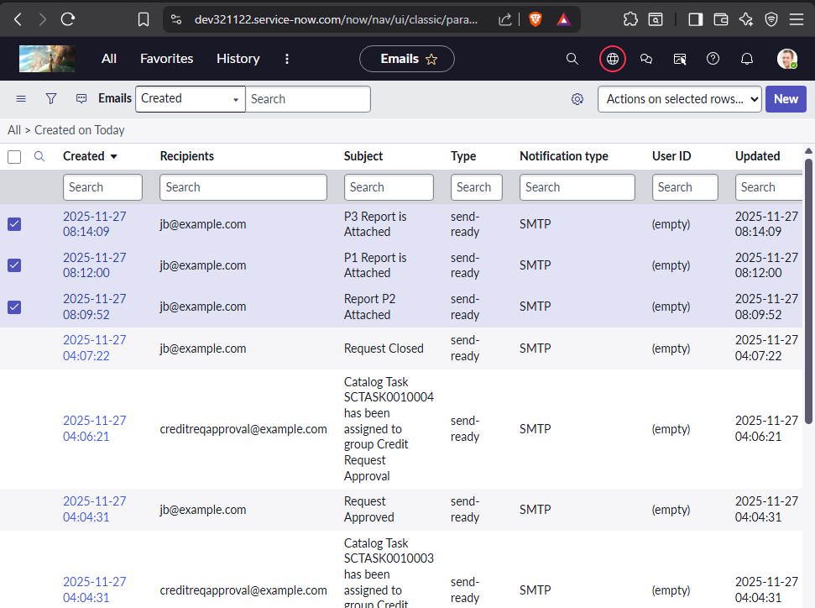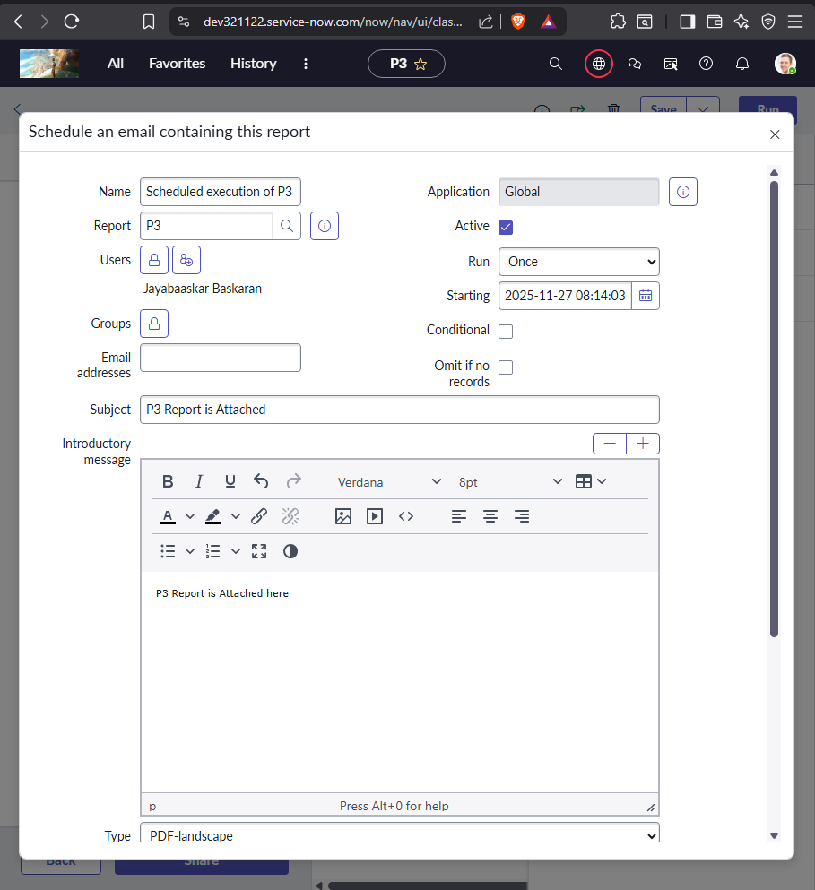Check if triggered on scheduled time
4. 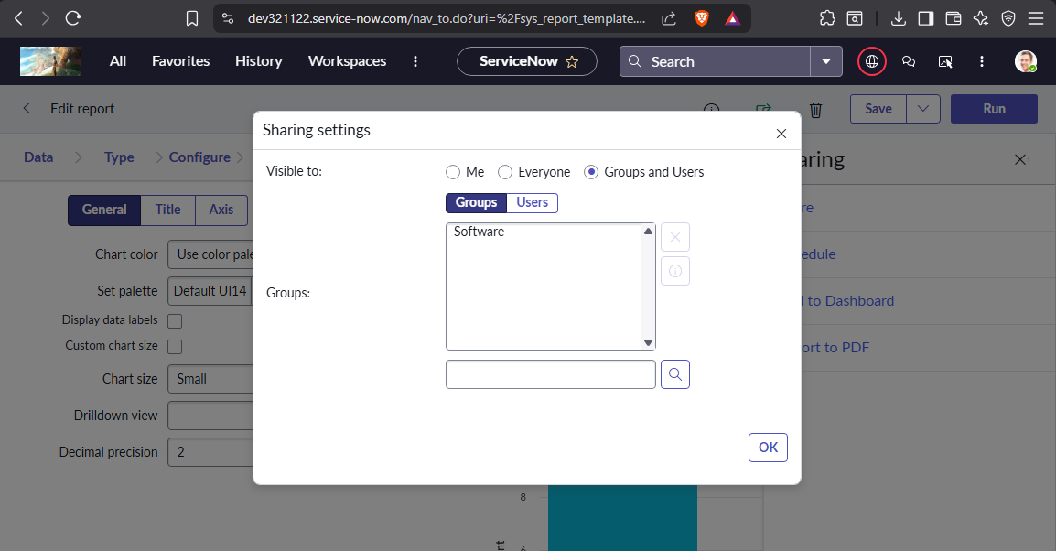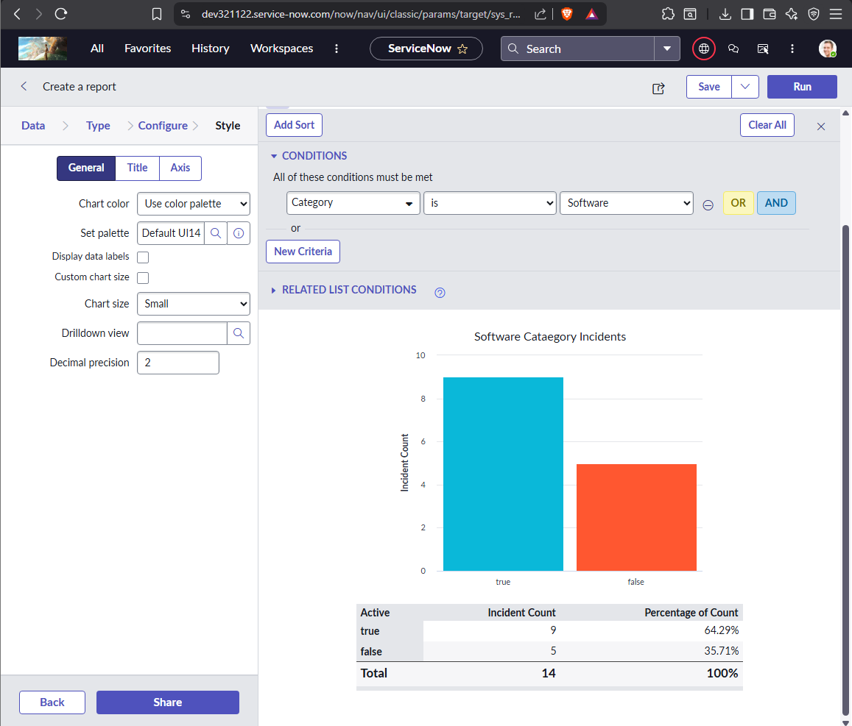Create a report to Find a software category incident in bar graph and share it and publish it to groups
5. Create Notification to opened by user when incident is inserted.
   * Sub : IncXXXX123 has been created.
   * 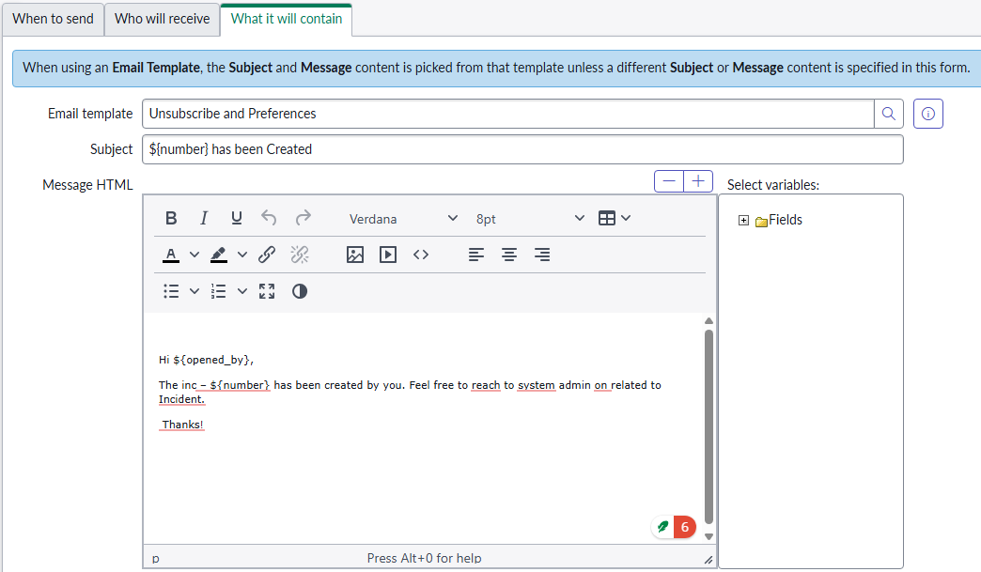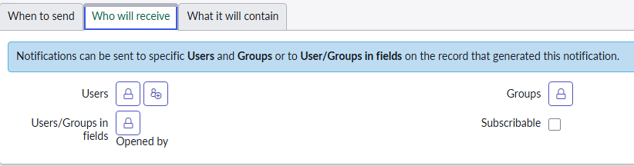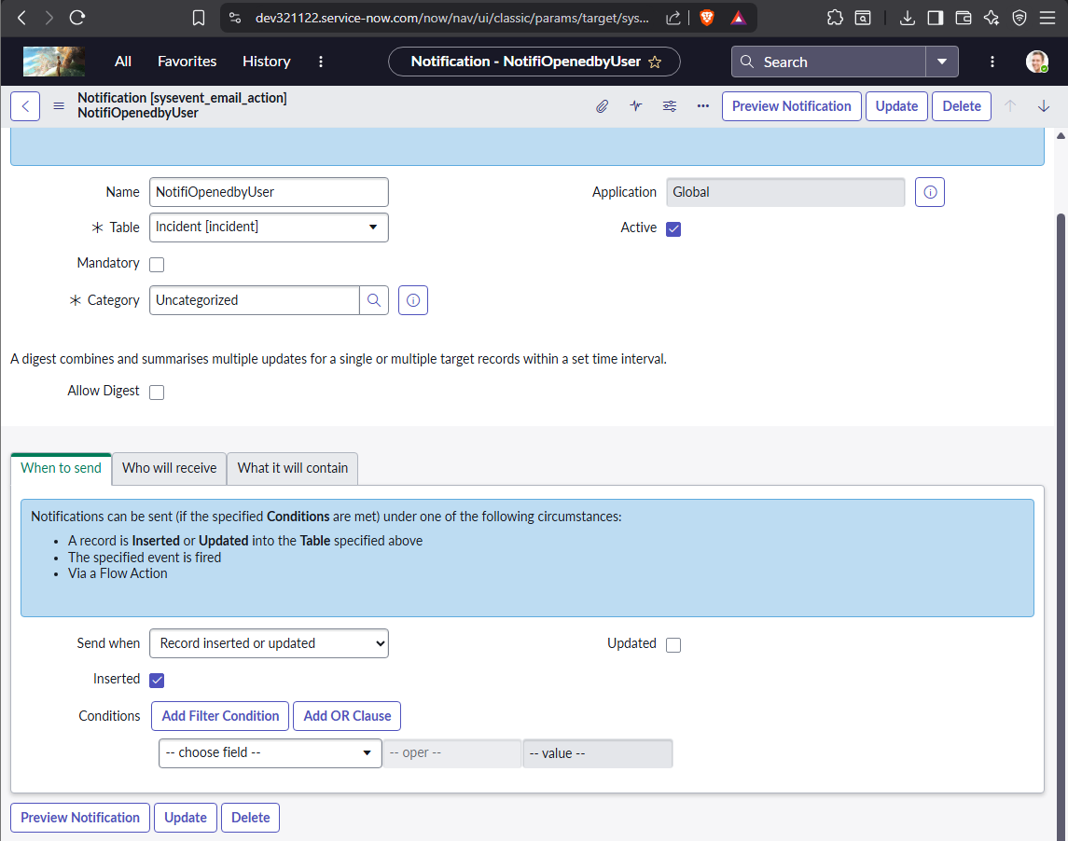Body : Hi XXXX, The inc –number has been created by you. Feel free to reach to syst em admin on related to Incident. Thanks!
   * 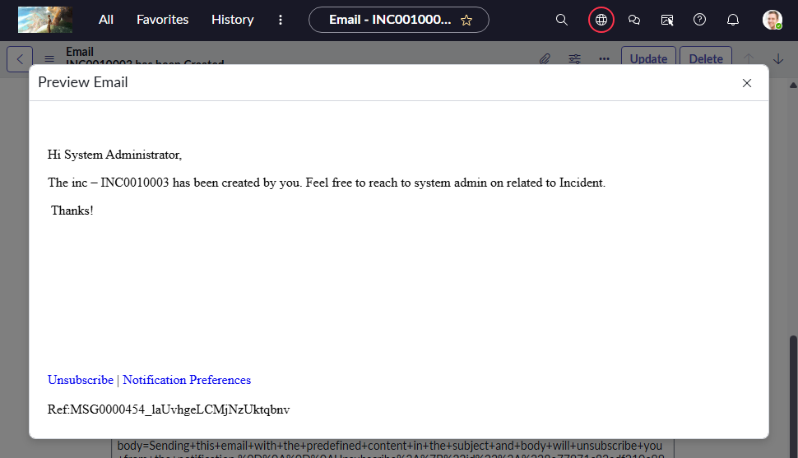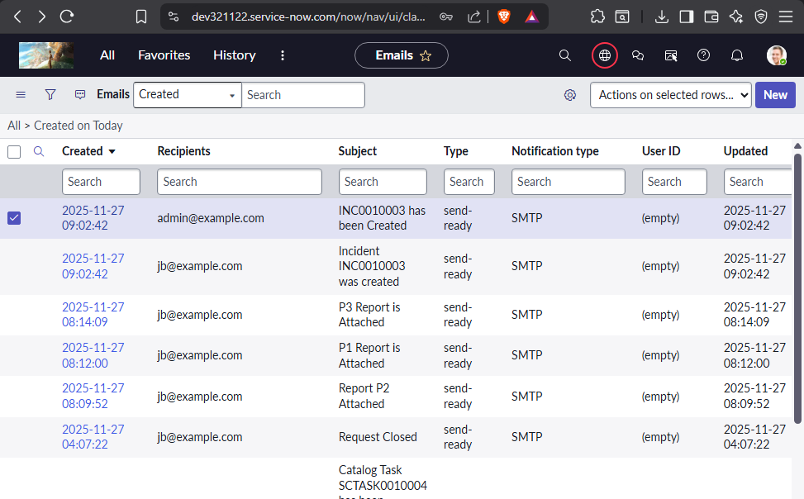Email Trigger check – All > System Logs > Emails.

1. Create a notification on update of incident to opened by. with the same body content as above.
   * Sub : IncXXXX123 has been updated.
   * 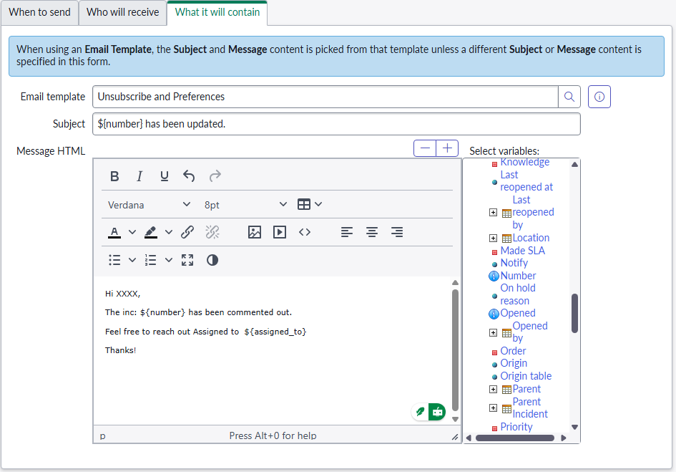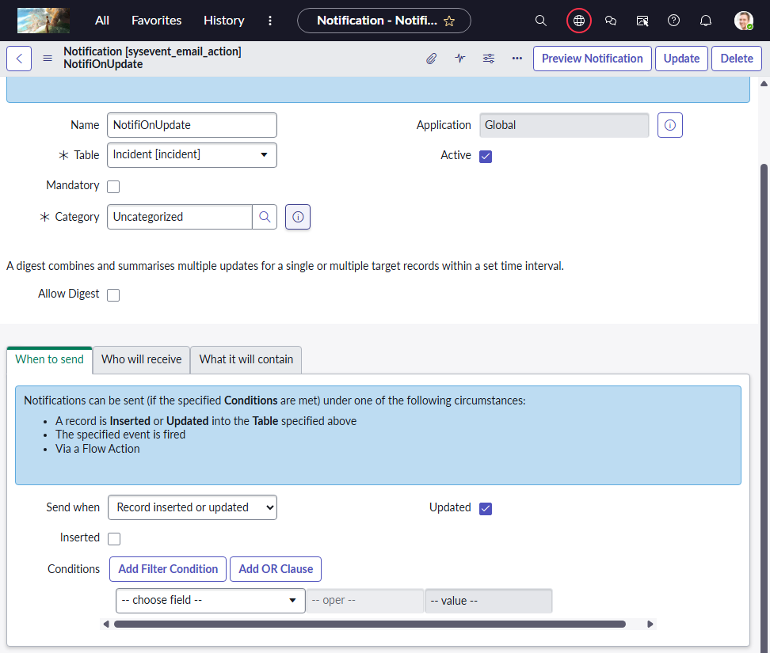Body : Hi XXXX, The inc –number has been commented out Feel free to reach out Assigned to {assigned to person name} Thanks!
   * 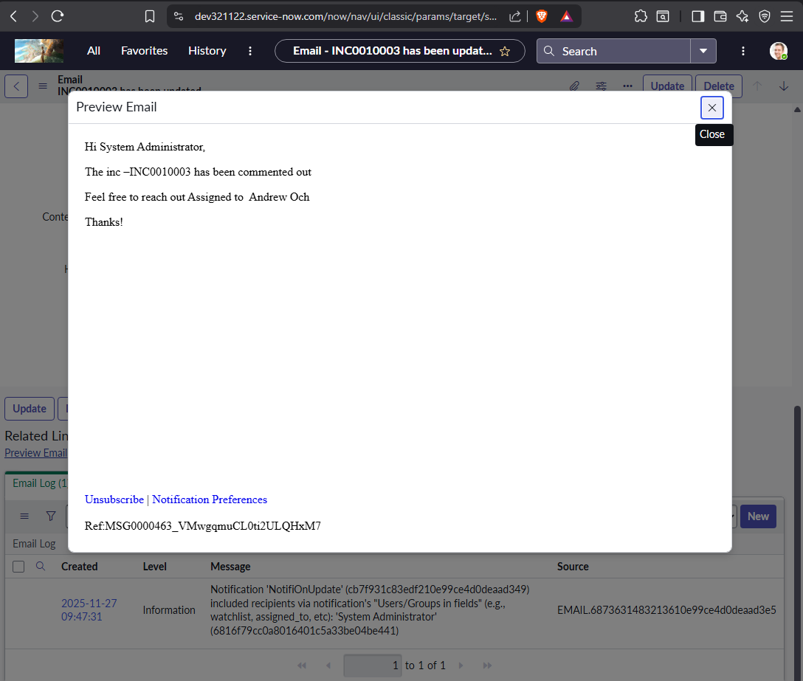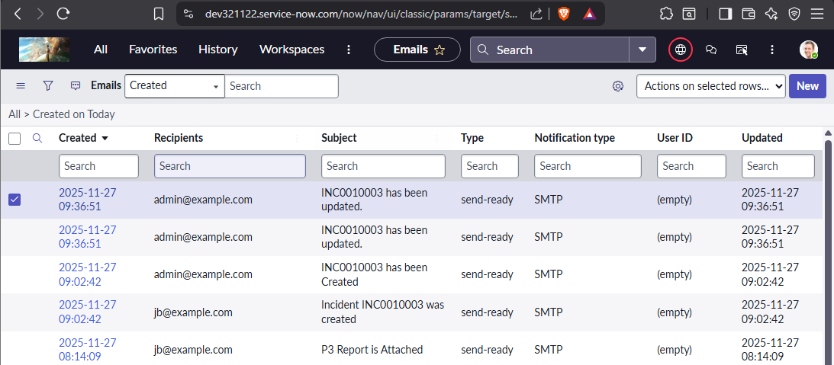Mail Log Check